QUESTION 1
Key points：07 - Search1-Blind.pptx & 08 - Search2-Heuristic.pptx

Answer：

- completeness: does search method always find a solution if one exists.
- time complexity: the number of generated nodes.
- space complexity: the maximum number of nodes in memory.
- optimality: does search method always find a least-cost solution.

(b)
BFS:
- completeness: Yes, if b(branching factor) is finite.
- time complexity: O(b^{d+1})
- space complexity: O(b^{d+1}) (keep every node in memory)
- optimality: Yes, if cost=1 per step.

DFS:
- completeness: No, fails in infinite-depth spaces. Complete in finite-depth space.
- time complexity: O(b^{m})
- space complexity: O(bm) (linear space)
- optimality: No.

IDS:
- completeness: Yes.
- time complexity: O(b^{d})
- space complexity: O(bd)
- optimality: Yes, if cost=1 per step.

(c)
IDS: IDS is close to BFS in speed and DFS in space. When the search results are obtained, the search depth can be guaranteed to be the smallest. IDS is an optimization scheme of DFS, which can be applied when the search depth has no definite upper limit.
A*: A* is an acceptable best-first search, and its evaluation function can find the shortest path.

Both are complete and optimal
A* should be quicker and have a small time complexity.
IDS has a low space complexity (A* keeps all nodes in memory).
A* requires a heuristic which will affect its performance.
A* fringe can get exponentially bigger.

(d)
An admissible heuristic never overestimates the cost to reach the goal.
Manhattan distance is one of these admissible heuristics.It is the number of moves between a tile and its goal location.
Then we sum up the Manhattan distance of each tile and get total Manhattan distance,which is h(n).

(e)
- G2 is a suboptimal goal state in the fringe.
- n is an unexpanded node in the fringe on a shortest path to an optimal goal G with true cost C*.
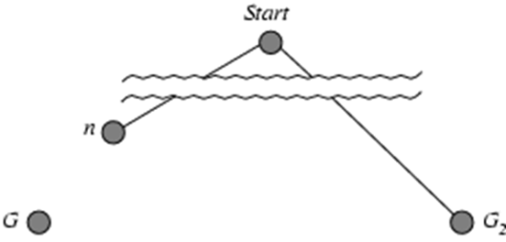
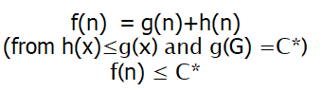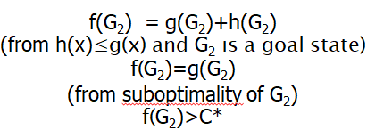

- f (n) ≤ f(G2), and A* will never select G2 for expansion

QUESTION 2
Key points:
https://secure.ecs.soton.ac.uk/noteswiki/images/COMP6231_Logic.pdf
https://secure.ecs.soton.ac.uk/noteswiki/images/ProbabilisticReasoning.pdf

Answer:
(a)
- tautology: A formula ф is called a tautology if for all possible valuations v, v(ф)=1.
- contradiction: A formula ф is called a contradiction if for all possible valuations v, v(ф)=0.
- So many, such as ~ф.
ф | ~ф
T | F
F | T

- Not equivalent.
p | q | ~p | ~q | p→q | ~(p→q) | ~p^~q | ((~p^~q) v q )
T | T | F | F | T | F | F | T
T | F | F | T | F | T | F | F
F | T | T | F | T | F | F | T
F | F | T | T | T | F | T | T

(b)
1.
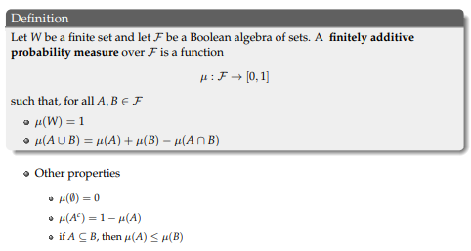
2.
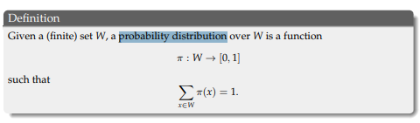
(c)
1.
- we say that A is semantic consequence of KB, or that KB entails A denoted KB |= A.
- When KB entails A, if every valuation (model) that makes all the formulas in KB true also makes A true. This means that Mod(KB) ⊆ Mod(A).

2.The simplest algorithm enumerates all the models of KB and A, and checks if
Mod(KB) ⊆ Mod(A)

3.2^{n}

QUESTION 3
Key points: https://secure.ecs.soton.ac.uk/noteswiki/images/ProbabilisticReasoning.pdf

Answer:
- P(W|~S) = P(W|~S, M)P(~S)P(M) + P(W|~S, ~M)P(~S)P(~M)
= 0×0.5×0.9 + 0×0.5×0.1
= 0

- P(R, W, ~M, S) = P(R|W)×P(W|~M, S)×P(~M)×P(S) = 1×0.7×0.1×0.5 = 0.035

- P(W|~M) = P(W|~M, S)P(~M)P(S) + P(W|~M, ~S)P(~M)P(~S)
= 0.7×0.1×0.5 + 0×0.1×0.5
= 0.035

- P(W) = P(W|M, S)P(M)P(S) + P(W|M, ~S)P(M)P(~S) + P(W|~M, S)P(~M)P(S) + P(W|~M, ~S)P(~M)P(~S)
= 0.2×0.9×0.5 + 0×0.9×0.5 + 0.7×0.1×0.5 + 0×0.1×0.5
= 0.09 +0.035
= 0.125

- P(R) = P(R|W)P(W) + P(R|~W)P(~W) = 1×0.125 + 0.1×0.875 = 0.2125

- conditional independence: two random variables X and Y are conditionally independent given Z, if P(X, Y|Z) = P(X|Z)×P(Y|Z).

(g)
Probability of a meeting running late on given being able to work and probability of being silence outside the office are conditionally independent.
W
M
S

QUESTION 4
Key points: 10 - CSP.pptx & 12 - AlphaBeta.pptx

Answer:
(a)&(b): 图灵测试优点和中文屋。reading都有，就不写了。

(c)
- Choose the most constrained variable to assign value to next.
- The most constrained variable is the variable with the fewest remaining legal values and this variable is most likely to prune the search tree.

(d)
1.
- Value of game of MAX player is 3.
- The first move of MAX player is A.
- The best next move of MIN is B.

2.
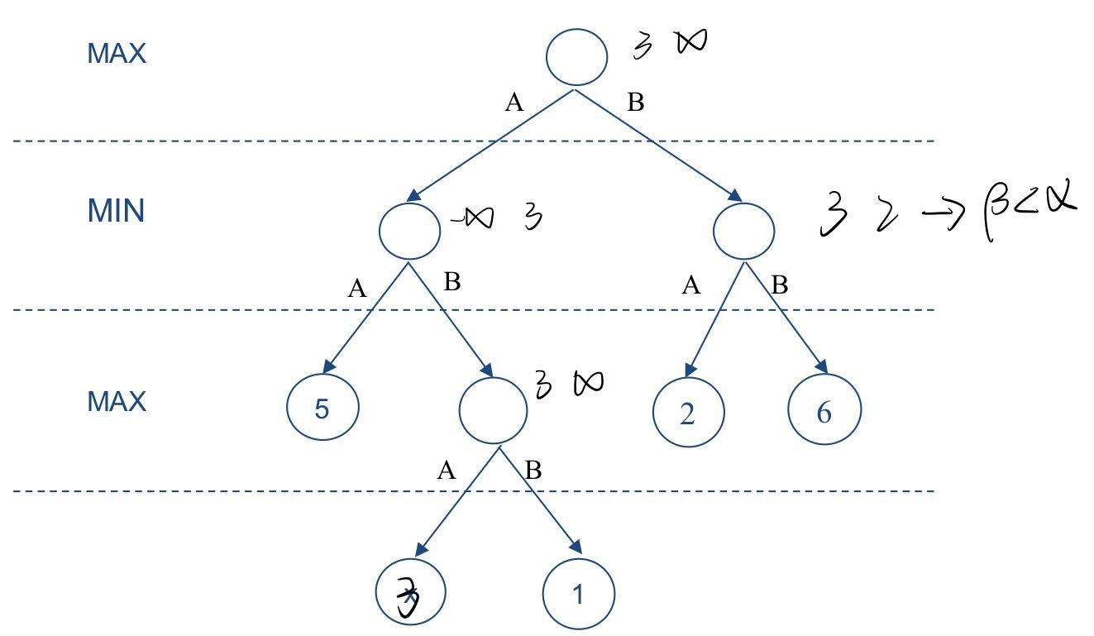
- According to alpha-beta pruning algorithm, MAX affect α and MIN affect β. When β ≤ α, prune the branch.
- It can be seen from the graph, when decide whether it is necessary to evaluate the last node, where α = 3 and β = 2. Since β ≤ α, prune the branch and there is no need to evaluate the last node.

- x < 2, that is x = 0 or 1.

